Factory method pattern example

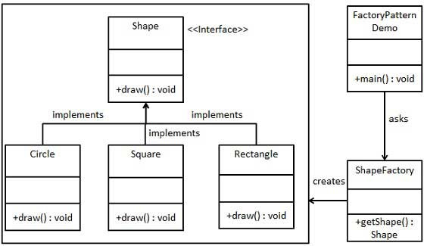

*Shape.java*

public interface Shape {

void draw();

}

*Rectagle.java*

public class Rectangle implements Shape {

@Override

public void draw() {

System.out.println("Inside Rectangle::draw() method.");

}

}

*Square.java*

public class Square implements Shape {

@Override

public void draw() {

System.out.println("Inside Square::draw() method.");

}

}

*Circle.java*

public class Circle implements Shape {

@Override

public void draw() {

System.out.println("Inside Circle::draw() method.");

}

}

*ShapeFactory.java*

public class ShapeFactory {

//use getShape method to get object of type shape

public Shape getShape(String shapeType){

if(shapeType == null){

return null;

}

if(shapeType.equalsIgnoreCase("CIRCLE")){

return new Circle();

} else if(shapeType.equalsIgnoreCase("RECTANGLE")){

return new Rectangle();

} else if(shapeType.equalsIgnoreCase("SQUARE")){

return new Square();

}

return null;

}

}

*FactoryPatternDemo.java*

public class FactoryPatternDemo {

public static void main(String[] args) {

ShapeFactory shapeFactory = new ShapeFactory();

//get an object of Circle and call its draw method.

Shape shape1 = shapeFactory.getShape("CIRCLE");

//call draw method of Circle

shape1.draw();

//get an object of Rectangle and call its draw method.

Shape shape2 = shapeFactory.getShape("RECTANGLE");

//call draw method of Rectangle

shape2.draw();

//get an object of Square and call its draw method.

Shape shape3 = shapeFactory.getShape("SQUARE");

//call draw method of circle

shape3.draw();

}

}

Link:

<http://www.tutorialspoint.com/design_pattern/factory_pattern.htm>